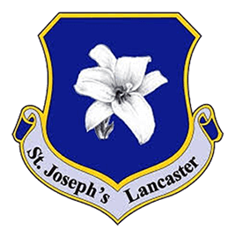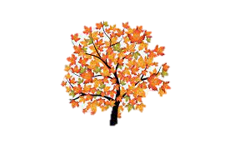

**Science**

In Science our focus will be animals and their habitats. We will learn why animals live in certain areas, and how they survive there. We will make comparisons between different habitats and we will work scientifically by comparing different animals.

We will be focussing on Emily Williamson as our focus scientist. Discussing the impact she had on how we view and understand animals and their habitats.

**Supporting your child with their learning**

* Reading at home – we encourage our children to read at home at least 3 times a week. Make sure to **sign your child’s reading diary** when you listen to them read at home.
* Learning logs – each week we send homework tasks, linked to the learning that has taken place during the week. Try to complete as many of those tasks at home.

**English**

We will begin our year by focusing on a range stories with familiar settings. We will be discussing what makes us worried or nervous, thinking of worry-monsters to help us deal with them, and then writing stories about them. After this, we will be looking at non-chronological reports about our local area and writing our own reports on it too. To finish the half term, we will be creating a poster to encourage people to visit our local area. This links to our Geography topic of ‘Our local area - Skerton’.

**Autumn 1: Learning in Year 2**

**Geography**

This half term we be focusing on Geography. We will be exploring our local area, looking at our school grounds and our journey to school. Simple field work will take place, whilst looking at maps of Skerton. Following on from this, we will be giving each other simple instructions to move to another place and creating a course for a programmable toy to move through.

**What we are reading this half term:**

The Very Hungry Worry Monster

* Rosie Greening

The Jolly Witch

* Dick King Smith

The Timdims of Rubbish Island

* Sally Gardner

**Maths**

In maths, we will be looking at place value. We will be working on recognising and writing 2-digit numbers up to 100, embedding our knowledge of exchanging ones for tens and vice versa. We will be using different equipment to represent our numbers, such as Base 10, number fans and counters. Once we have finished using concrete resources, we will be introduced to the part- part-whole model. This allows us to visually see the different parts of numbers. Which leads us to learning about addition and subtraction with 1-digit from 2-digit numbers. We will also be looking at measurements using cm, m, g and kg. We will be using different resources to measure different items from around the classroom and outdoor area.

**Computing**

To start off our computing lessons, we will be exploring what computing systems and networks are, and how they help us in everyday tasks. We will become more familiar with different IT components around us and how to use them safely.

**PSHE**

Our PSHE topic is ‘Healthy eating’ where we will be learning all about the different food categories and how they affect the human body

We will also be looking at how people are all different, and how we can be welcoming and inclusive of them.

**P.E**

In PE we will focus on two stories to support our fundamental movement skills. ‘Supertato’ and ‘Lost and found’. We will practise skills such as throwing a ball underarm and overarm. More ball skills include catching, bouncing, kicking and rolling.

We will practise moving our bodies by hopping, skipping, running and jumping.

**Art**

In Art this half term we will develop our knowledge of prints. We will use inspiration from nature, including animal prints, using a range of media to recreate what we see outside.

**R.E**

During R.E. we will learn about the different stories within the Bible. Our focus is the Christian belief that all that exists comes from God, the Creator, who Christians call Father, and that this belief is found in Scripture and the prayers of the Catholic Church.The Church teaches that with this belief comes responsibilities to take care of the world God has gifted to humanity.

We will be looking at the different symbols of God’s love and how he is present in all that we do.

**Phonics**

In the first few weeks we will review Phase 4 and Phase 5 sounds. We will then move onto Phase 6 Grapheme Phoneme Correspondence (GPC’s). Graphemes are the written letters, Phonemes are the sounds that those letters make. Look at our class page for useful phonics websites.

**Music**

We will be following “Charanga” to focus on our rhythmic skills. Our theme will be on hands, feet and heart. We will be playing percussion instruments as well as singing in our lessons.